**Course Project – Energy**

Shaun Pritchard

Rasmussen College

G328/EVR3410

Marshall Bowles

May 31, 2020

**Course Project – Energy**

**Do you believe that the government should establish a national energy policy?**

Yes, I believe having a national energy policy would be a very good idea. With that being said there would be many things that we have to attribute and keep an eye on. Many policies get politicized and many corporations with spending power can buy their ways out of specific situations regarding avoiding sustainability. We would need a policy that would not attribute lobbyists nor private incentives. Politics would need to be removed for the common good!

We would also have to consider the factors of legality in that we would not propose any infringements of consumers' or organizations' rights or that denies specific companies or organizations protected freedoms. National energy policy would need to be rigorous in exclaiming a unified plan that would involve a common goal. It would need to facilitate a way for people to continue to aspire and strive for higher standards of living with greater freedom and dignity. While transforming our current infostructure and practices to more sustainable actions that would reduce energy and resources.

Allocate resources to develop a phased mission capable and unique enough to involve the entire nation its people, and companies that make up the nation. I do not believe this is one way in which we would Implement specific practices for certain organizations and not consumers or only to consumers and not specific organizations.

Break down common factors of states and locality, use data to drive metrics in tracking the operation, resources for public and commercial purposes, and incentivize for each faction.

Set aside grievances and petty differences. Stop allocating blame and start working on unified solutions to solve issues once they are identified or ones that have been known. furthermore, we would need a government initiative to bring us all together while keeping their place as a representation or an extension of the people for this work correctly.

**How would you construct this policy?**

To establish a sound national energy policy first, we would need to implement the stated problems in a format we can build a solution upon. dividing out specific variables that facilitate and embody the principles standards of national policy as described above with a common goal. The common goal to reduce energy, waste, and usage that would involve new sustainable practices while implementing Innovation and incentives that facilitate environmentally sound utilization and sustainability. Through this, we could seek balance in government, infrastructure, business, and private consumer levels.

If a national policy existed that incentives and declared that all infrastructure energy sources in respected states and areas. To utilize and transform into renewable energy sources first. Implement action to phase out the nonrenewable energy source. Only using these sources for back up and emergency.

It is reported that it would take $4.5 trillion to convert USA infrastructure to 100% renewable energy source over the next 10 years. (E360, 2019). So where can we get this money? How can business stay in business for transforming? What creative ways can we help adjust for this cost, to take action, and make it a reality?

Formulate best practices, incentives, and overhaul audit systems for each type of business setting sustainable guidelines. Giving them a choice to sign up and pledge new sustainable practices. There are 4 types of business Service, product, manufacturing, and hybrid (Accounting Verse, 2020). The government can use incentives, tax breaks, and recognition to create public awareness of those companies who pledge to practice more sustainable acts.

New protocols or audit systems tracked and implemented through data analysis and technology could provide public resources of awareness. We would need to find a way to split the cost attributed to the public deficit and make it worth the company owner's time.

Essentially if companies pledged to a unified movement through the policy to use sustainable resources, services and followed the new protocols for their respected industry. Companies could receive tax incentives to lower their product prices making it more efficient for consumers to make buying decisions at a lower cost. Where are those businesses that did not follow the trend would still have the choice at the risk of the markets?

To break this problem down we need to infer a multipart polynomial equation based on consumers, business, government, and infrastructure. Ultimately, we need a policy that would incentivize the transformation of nonrenewable energy sources and technology to renewable energy sources. Renewable energy sources have proven to be more efficient. The only catch is that the cost of business to convert could cost time, resources, and money that would set a business back.

We need to devise a phased program that would incentives using natural sustainable renewable energy (solar, hydro, thermal) solutions as primary energy sources. while utilizing non-renewable energy (oil, natural gas, coal) as backups only needed for emergencies. We would need each state to use data-driven practices to permeate results that facilitate the common end goal or transformation over 10 years. Also, to implement a new audit system for the variety of businesses to implement sustainable practices within their business and provide public information to incentivize consumers to make smarter purchases with companies who are converting and following more sustainable guidelines.

**Phase I** - Implement stated problems, collect information on each state energy needs, calculate resources to convert to more sustainable infrastructure, running the inferences based on each State's Collective needs divided by the collective end goal of the nation, discuss incentives, planning, and development of consumer-level data resources, calculate which enable sources are available for specific states, calculate resources, time, and finances needed for each state to comply and transform, establish deadlines, policies to incentivize companies transforming, and higher rate, taxes, and locks on trade and contracts for those. From a government level, we could create a department to implement oversight and see this through.

**Phase II** – Implement the transformation. This is where we phase out the conversion maximums of enabling renewable energy (solar, hydro, thermal). Implement infrastructure overhaul and business who may switch services and practices. Use marketing to highlight companies, manufactures, and infrastructure making the change to keep them in a positive light.

**Phase III** – Complete transformations while setting new benchmarks to refine sustainability within business, manufacturing, services, public, and infrastructure.

Out of 50 states in each state, we have commercial and public sectors. Each state has different factors that create unique problems on their own. States have different seasons, weather patterns, and needs for diverse energy resources concerning their demand in public use and manufacturing. All related to the multiple respected levels of consumers, business, government, and infrastructure

**Consumer-level** – To implement resources and data-driven solutions that could bring public awareness to those companies spending time and resources on the transformation. We as consumers and private citizen need to make conscious decisions on how to use our buying power with those companies seeking to transform

**Business level** – Rethinking technology cost a lot of money, time, and resources there are over 30 million smalls to mid-sized business in the U.S.A with under 500 employees. Provide lifeblood to our nation and the world (Fundera, 2020). and only 8000 major global size cooperation with more than 500 employees (Fundera, 2020). Typically, major businesses set up manufacturing overseas in countries like China where there is no environmental regulation, cheap labor, and no taxes. We need these businesses to attract more money, value, and success for being sustainable here in the U.S.A.

**Government** – essentially the gatekeepers of information, public awareness, and resources to be used and implemented to converting the infostructure and providing incentives through tax breaks, accountability, recognition, and business. Our government would need to choose sustainable companies and contractors over non-sustainable countries. This would set the benchmark and example for business owners to follow. This variable would need to cut out bloated bureaucracy and politicization.

**Infrastructure** – Currently we have technology in place and are only utilizing 18% of our potential through renewable energy sources. We need to find a way to incentivize a transformation that will not cost businesses to lose money and will employ new implementations on resources to sustain them moving forward as shown from the U.S Energy

Information Administration below *(U.S Energy Information Administration, 2020).* 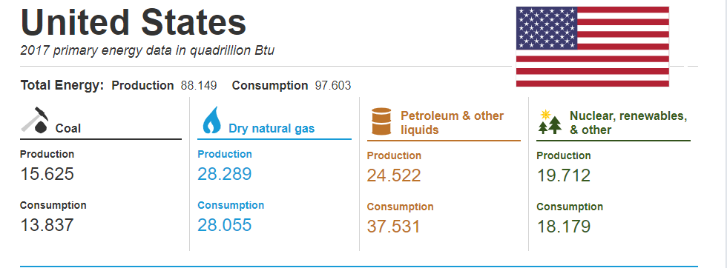

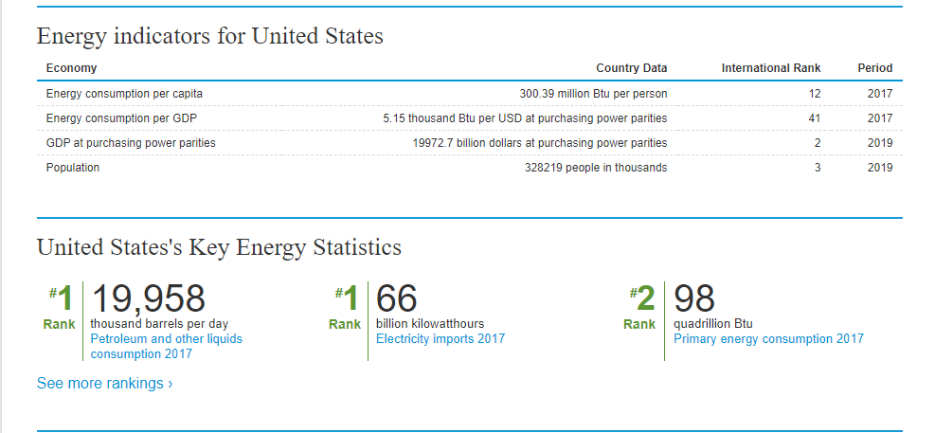

This policy would have to implement structure and new capability requirements for each category factor. Innovation, transformation all takes time and money. If we could allocate resources to those making the effort as opposed to those who are not trying. We create a fair market environment. Regardless it is in my personal opinion that some action needs to be taken. There are many ways in which a new trend followed by sound practices as suggested above can facilitate this change. We need to move beyond awareness to achieve this and attain perspective and balance.

We need to spark a trend that will incentivize business, incentivize innovation, and incentivize the people to take part in making better-informed decisions. One day I would like to see new technology that would let us recycle and clean plastic at our homes. To ether sell back cleaned material or use in 3D printing.

I would like to see major global and small corporations ensuring they are not cutting corners. Bringing real value to the market through new products and services that follow sustainable practices people can trust. For the ability for America to set the standard for the rest of the planet to follow suit. Ensuring everyone is doing part to reduce the maximum amount of waste and energy.

# References

Accounting Verse. (2020). *Types and Forms of Business*. Retrieved from www.accountingverse.com: https://www.accountingverse.com/accounting-basics/types-of-businesses.html

E360. (2019, 06 28). *Shifting U.S. to 100 Percent Renewables Would Cost $4.5 Trillion, Analysis Finds*. Retrieved from www.yale.edu: https://e360.yale.edu/digest/shifting-u-s-to-100-percent-renewables-would-cost-4-5-trillion-analysis-finds

EWG. (2016, 3 2). *Purdue's GMO Study: Biased Data, Bogus Findings*. Retrieved from www.ewg.org: https://www.ewg.org/agmag/2016/03/purdues-gmo-study-biased-data-bogus-findings

Fundera. (2020, 4 18). *How Many Small Businesses Are in the U.S.? (And Other Employment Stats)*. Retrieved from www.fundera.com: https://www.fundera.com/blog/small-business-employment-and-growth-statistics

U.S Energy Information Administration. (2020). *Total Energy Consumption*. Retrieved from www.eia.gov: https://www.eia.gov/international/overview/country/USA